|  |  |
| --- | --- |
| Subject: Data Analytics and Visualization Lab | Course ID: CSL-601 |
| Semester: VI | Course: AI & DS |
| Laboratory: 407 | Name of teacher: Prof. Gitanjali Korgaonkar |
| Name of Student: Ayush Gupta | Roll No: VU2S2324001 |

**EXPERIMENT NO. 8**

**Aim:**

To implement Time Series Analysis (ARIMA)

**Theory:**

**Time Series Analysis:**

Time series data consists of observations collected sequentially over time at regular intervals. It is used for forecasting future values based on past patterns. Common applications include stock market predictions, weather forecasting, and demand forecasting in businesses.

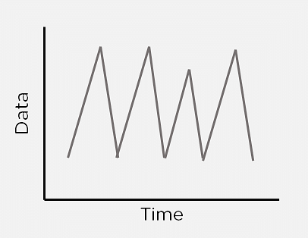

Time Series

A **Time Series Analysis** extracts valuable characteristics from such data by identifying patterns such as trends, seasonality, and irregularity.

**Components of Time Series Analysis:**

1. **Trend:** A long-term increase or decrease in the data over time. Examples: stock prices, company production.
2. **Seasonality:** Regularly repeating patterns in the data occurring at fixed intervals. Examples: holiday shopping trends, ice cream sales in summer.
3. **Irregularity:** Unpredictable fluctuations that do not follow trends or seasonal patterns. Example: economic crashes, natural disasters.
4. **Cyclic:** Oscillations that last more than a year but may or may not be periodic. Example: business cycles.
5. **Stationarity:** A time series is stationary if its mean, variance, and covariance remain constant over time. Stationary data is required for accurate time series forecasting.

**ARIMA Model (Auto-Regressive Integrated Moving Average):**

ARIMA is a widely used forecasting model that predicts future values based on past data and forecast errors.

It consists of three main components:

1. **Auto-Regressive (AR) Model:** Uses past values to predict future values.
2. **Integration (I):** Differencing is used to make the time series stationary.
3. **Moving Average (MA):** Uses past forecast errors to improve predictions.

The ARIMA model is represented as **ARIMA (p, d, q)**, where:

* **p**: Number of lag observations for autoregression.
* **d**: Number of times differencing is applied to make the series stationary.
* **q**: Number of lagged forecast errors in the model.

**Advantages of ARIMA:**

* **Accurate Forecasting:** ARIMA is widely used for precise time series forecasting.
* **Handles Trends & Seasonality:** It captures trends and patterns effectively.

**Disadvantages of ARIMA:**

* **Computationally Intensive:** ARIMA can be slow for large datasets.
* **Assumes Linear Relationships:** It may not work well for complex non-linear data.

**Learning Objectives:**

* Understand Time Series Analysis and its components.
* Learn how to implement ARIMA for forecasting.
* Analyze real-world time series data using Python.

**Conclusion / Learning Outcome:**

Time Series Analysis using ARIMA has been successfully implemented in Python. The model was trained on the **Random Sales Dataset**, evaluated using **RMSE**, and visualized with **predicted vs. actual values**.

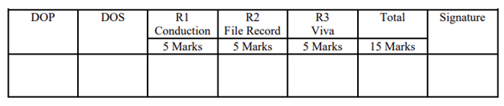

**Program and Output:**

**Step 1: Load and Visualize Time Series Data:**

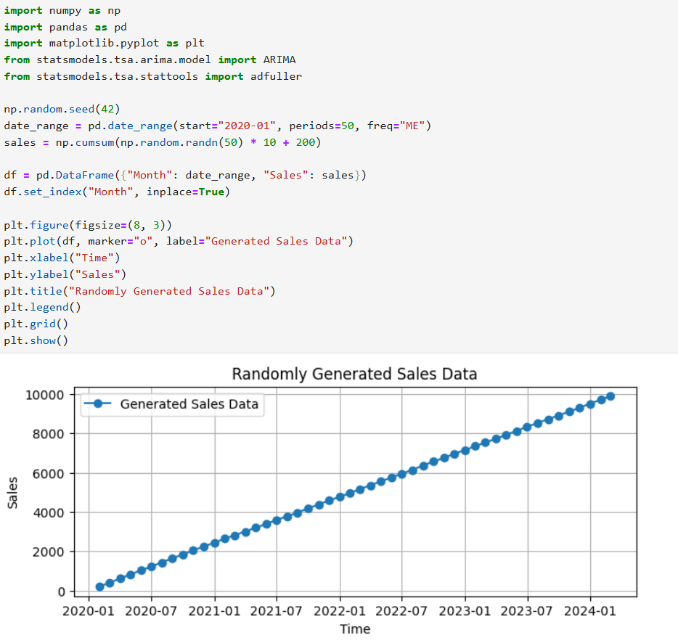

**Step 2: Check for Stationarity using Moving Average:**

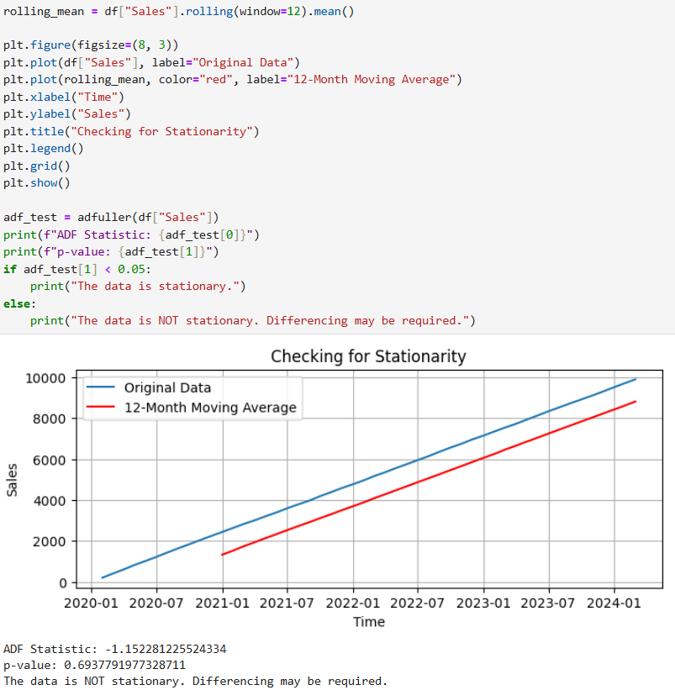

**Step 3: Fit an ARIMA Model:**



**Step 4: Rolling Forecast using ARIMA:**

